<TEAM LOGO>

CODE MASTERS

Good Health and well-being

Maternity Mate

|  |  |
| --- | --- |
| IT Number | Name |
| IT22115720 | Wickramasurendra K.D.A.D |
| IT22102546 | Nimesh S.D.S |
| IT22119230 | Weerasinghe D.N.T |
| IT22347862 | Dilshan W.P.S.S |

Y3S1_SE_WE_67

User Experience Engineering SE3050

Department of Computer Science and Software Engineering, Faculty of Computing, Sri Lanka Institute of Information Technology (SLIIT)

# Declaration

We declare that this is our own work, and this report does not incorporate without acknowledgment any material previously submitted for a degree or diploma in any other university or institute of higher learning, and to the best of my knowledge and belief it does not contain any material previously published or written by another person except where the acknowledgment is made in the text. Also, we hereby grant to Sri Lanka Institute of Information Technology the non-exclusive right to reproduce and distribute our report in whole or part in print, electronic, or another medium. We retain the right to use this content in whole or part in future works (such as articles or books).

|  |  |  |  |
| --- | --- | --- | --- |
| Student No. | Name | Date | Signature |
| IT22115720 | Wickramasurendra K.D.A.D |  |  |
| IT22102546 | Nimesh S.D.S |  |  |
| IT22119230 | Weerasinghe D.N.T |  |  |
| IT22347862 | Dilshan W.P.S.S |  |  |

# Abstract

<<It outlines the

problem,

the purpose of the report,

the main areas addressed and methodology

the general solution and

conclusion you will be defending. >>

Table of Contents

Declaration 1

Abstract 2

List of Figures 6

List of Tables 7

List Of Abbreviations 8

1 Introduction 9

2 Background 10

2.1 SDG selection 10

2.2 Design Purpose 10

2.3 Team Members 10

2.4 Contribution Table 10

3 Design Process 11

3.1 User Involvement 11

4 Milestone 1: Identify user groups 12

4.1 Persona(s) – 04 personas from a group 12

4.2 Empathy map(s) – 04 Empathy maps from a group 12

4.3 User stories – 04 User stories from a group 12

4.4 User flow(s) - 04 User flows from a group 12

4.5 Service Blueprint(s) – 01 Service Blueprint from a group 12

4.6 Identify the basic functionality of the proposed system 12

5 Milestone 2: Plan and conduct user research 13

6 Milestone 3: Verify the key-user flow(s) 14

6.1 Verify the identified functionality (Milestone 1) of the proposed system 14

7 Competitor Analysis 15

7.1 <Competitor 1> 15

7.2 Advantage 15

7.3 Disadvantage 15

7.4 Translation 15

7.5 <Competitor 2> 15

7.6 <and so on …> 15

8 Milestone 4: Sketching 16

9 Milestone 5: Wireframes, Prototype 17

9.1 Design 1 17

9.2 Design 2 - accepted 17

9.3 High Fidelity Prototype 17

9.4 Design 1 17

9.5 Design 2 - accepted 17

10 Milestone 6: User Feedback for your Prototype 18

11 Milestone 7: Implementation 19

12 Requirement Specification 20

12.1 Usability Goals 20

12.2 User Experience Goals 20

12.3 Functional Requirements 20

12.4 Non-Functional Requirements 20

12.5 Hierarchical Task Analysis 20

12.5.1 <Task 1> 20

13 Design Principles 21

14 Project Management 22

14.1 Meetings 22

14.2 Risk Management 22

14.3 Milestones 22

14.4 Problems Encountered 22

15 Conclusion 23

References 24

Glossary 25

Appendix 26

15.1 Initial User Survey Responses 26

15.2 Meeting Minutes 26

15.3 Record Keeping 26

15.4 Toggl tracking 26

15.5 Links to Google Docs / MS Teams 26

15.6 Contribution Table 26

**Tip #1:** The purpose of this template is to ensure you cover the main content required in your report. However, this report template is not absolute. Rather, it is a guide and you don’t have to follow it exactly. You can add or replace some sections if needed. Following this template exactly does not guarantee full marks. Marks depend on the quality of the content of the report.

**Tip #2:** There is no minimum or maximum page limit, Note, the report must be professionally and succinctly written with emphasis on clarity. Content that is not essential should not be included. There may be a suggested word limit for some sections.

**Tip #3:** Although not essential, you may choose your own document template to deliver a beautifully presented industry-ready report (e.g. Envato Elements or Microsoft Page Layout designs may be useful).

**Tip #4:** Read this whole document early in the course.

# List of Figures

# List of Tables

# List Of Abbreviations

# Introduction

This section provides and overview of your report. Describe briefly what to expect from this report.

# Background

## SDG selection

Describe the solution you are designing to the selected SDG.

* Provide some context on the project domain e.g. explanation, problems, and needs.
* Explain why you chose this project.
* Who are the users, why is this solution important and helpful to them?
* Describe the purpose and the design issues you addressed when designing this.
* Screenshots can help to provide visual cues.

## Design Purpose

Describe the goals you want to achieve from designing your GUI. Is it about user-friendliness? Usability? Efficiency? Attractiveness?

## Team Members

List the team members and their role.

## Contribution Table

Create a table that lists everyone’s contribution on each section. Multiple group members can contribute to any single section.

# Design Process

Explain the use of the Design thinking model

## User Involvement

Describe how you would involve the user in the user-centred design process. Remember that you may NOT actually survey real people for this assignment (due to lack of ethics approval). However, you should describe your plan on how you would involve them.

# Milestone 1: Identify user groups

## Persona(s) – 04 personas from a group

4.1.2 Persona- Persona of the Provide Health Education And Emergency Services

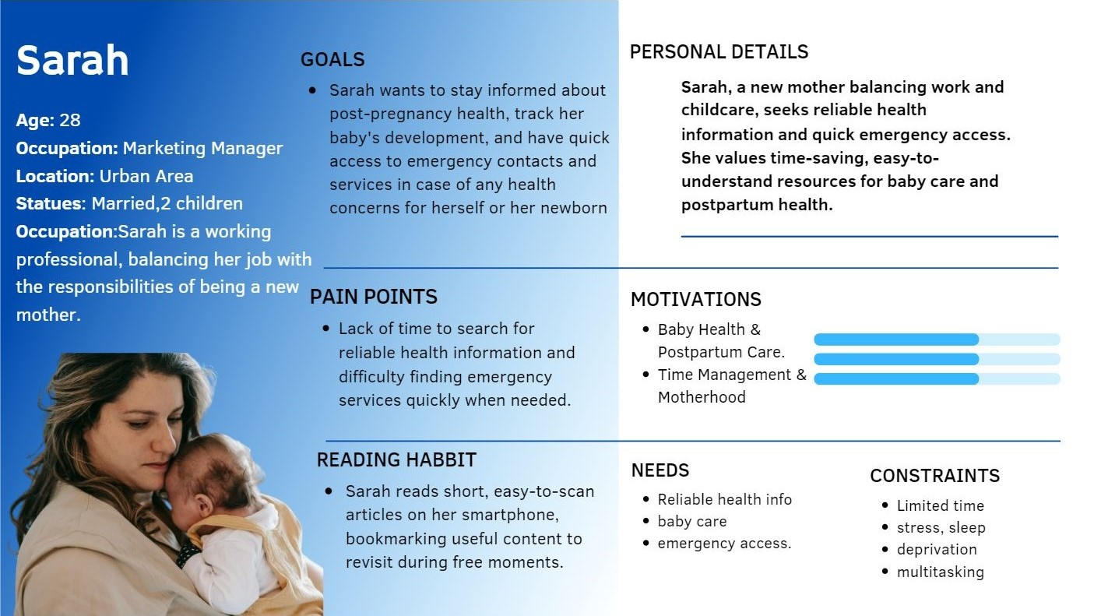

## Empathy map(s) – 04 Empathy maps from a group

**4.2.2 Empathy map – Empathy map Provide Health Education And Emergency Services**

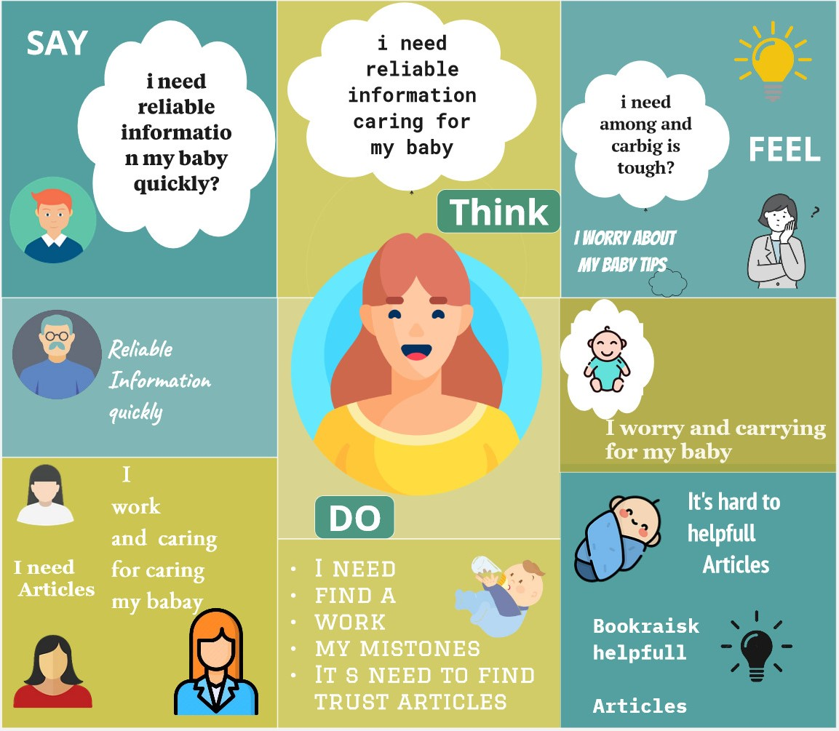

## User stories – 04 User stories from a group

**4.3.2 User Story for Provide Health Education And Emergency Services**

**As Sarah, a new mother,** I want to easily find reliable health information, So that I can make informed decisions about my baby’s health and well-being.

**As Emma, a new mother,** I want to have quick access to emergency contacts and nearby medical services, So that I can respond swiftly in case of any health emergencies.

**As Ann, a new mother,** I want to receive personalized health tips and articles based on my baby’s age and needs, So that I can focus on the most relevant and helpful information.

**As Juliet, a busy working mother,** I want to read quick and easy-to-understand articles, So that I can stay informed without spending too much time searching for information.

**As Mishel, a new mother,** I want to bookmark health articles that I find useful, So that I can easily revisit them when I have more time.

**As Janne, a new mother living in an urban area,** I want the app to automatically find the nearest emergency services based on my location, So that I can access help quickly, especially in unfamiliar places.

## User flow(s) - 04 User flows from a group

**4.4.2 User flow for Provide Health Education And Emergency Services**

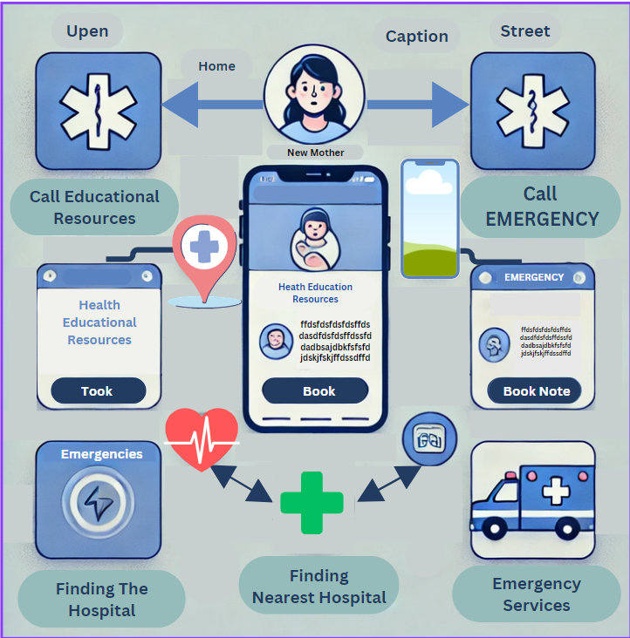

## Service Blueprint(s) – 01 Service Blueprint from a group

**Service Blueprint flow for Provide Health Education And Emergency Services**

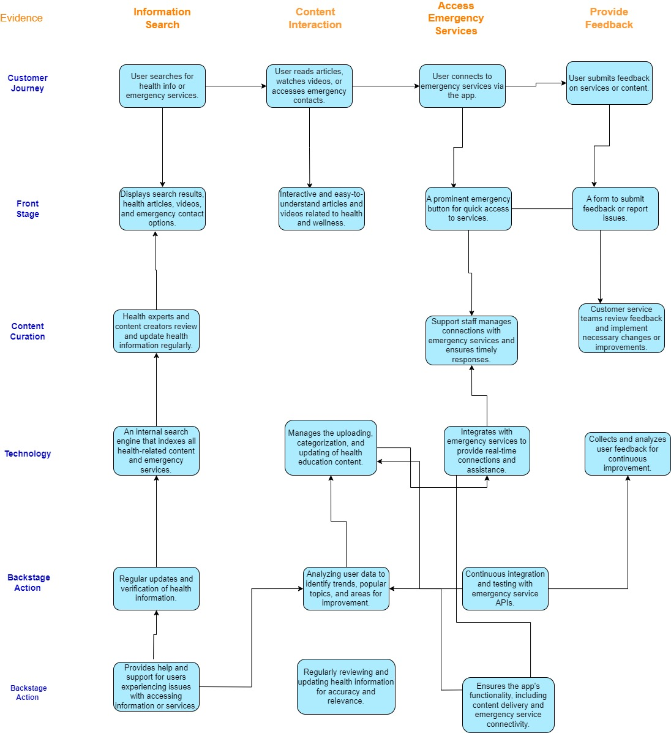

## Identify basic functionality of the proposed system

* Exercise Schedule Planner and Telemedicine Integration.
* Nutrition and symptom tracking.
* Health Information and Education Provider.
* Appointment and Emergency Service Management.

# Milestone 2: Plan and conduct user research

* + - 1. **Introduction**

The project focuses on developing a mobile application aimed at providing health education and emergency services related to maternal and neonatal care. We are testing this application to ensure that it meets the needs of our target users, primarily expectant mothers, healthcare professionals, and those interested in maternal health. The research will help us gather insights on user interaction with the app, identify usability issues, and understand user expectations. The results will be used to refine the app’s design, improve its usability, and ensure it effectively serves its purpose.

1. **Test Objectives**

The primary objectives of this user research are:

1. **Usability Evaluation**: To assess how easily users can navigate the health education modules and access emergency services within the app.
2. **Functionality Assessment**: To ensure that the emergency services, such as the SOS feature, are accessible and functional in real-world scenarios.
3. **User Satisfaction**: To understand how satisfied users are with the app, particularly in terms of content relevance and ease of use.
4. **Pain Points Identification**: To identify any challenges or pain points users experience while using the app, including issues with user interface (UI) design or functionality.
5. **Feedback Collection**: To gather user feedback on additional features or improvements they would like to see in the app.

#### **Methodology**

The user research will involve a combination of qualitative and quantitative methods, including interviews, video recordings, and questionnaires. We have selected four participants that align with the personas of our target users. The research will be conducted remotely, with participants using their own mobile devices to interact with the app. Data collection will occur through recorded Zoom sessions, digital questionnaires, and observational notes.

1. **Interviewing**

* **Purpose**: To gather in-depth qualitative data on user experiences, expectations, and feedback on the app.

**7.1 Questions About Preferences of Providing Health Education and Emergency Services from the Maternity Mate App**

1. What are your primary health concerns during your pregnancy?

* Open-ended
* I'm mostly concerned about maintaining proper nutrition and managing stress during my pregnancy. I'm also worried about how to handle any emergencies that might arise.

2.What kind of information do you expect to find in a pregnancy-related health app?

* Open-ended
* I would expect to find detailed information on diet, exercise, mental health, and emergency procedures. It would also be great to have weekly updates on what to expect in each trimester.

3.How do you currently manage your health and well-being during pregnancy?

* Open-ended
* I rely on advice from my doctor, online articles, and pregnancy books. I also try to eat a balanced diet and do light exercise.

4.What features would you find most valuable in a health education app?

* Open-ended
* A feature that tracks my pregnancy progress, offers personalized tips, and provides emergency contact information would be most valuable. I would also appreciate a section for mental health support.

5. Are there any specific challenges you face when accessing pregnancy-related health information?

* Open-ended
* It's sometimes hard to find reliable information that's tailored to my specific needs. I also get overwhelmed by the amount of information available online and wish there was a simpler way to get trusted advice.

6. How would you prefer to receive updates and notifications about your pregnancy?

* Options: Daily, Weekly, Only for Important Updates
* Weekly - I would prefer to receive weekly updates about my pregnancy progress and any important health tips.

7. What do you hope to achieve by using a pregnancy health app?

* Open-ended
* I hope to feel more confident and informed about my pregnancy. I want to ensure that I'm doing everything I can to stay healthy and that I have quick access to emergency services if needed.

8. How important is it for you to have a personalized experience in the app?

* Likert Scale: 1 - Not Important, 5 - Very Important
* 5 - It's very important to me. I would like the app to adapt to my specific situation, such as my trimester and any health concerns I might have.

9. What concerns do you have about using a health app during your pregnancy?

* Open-ended
* I'm concerned about the accuracy of the information provided and whether the app will be easy to use. I also want to ensure that my personal data is kept secure.

10. How likely are you to use an emergency SOS feature in the app?

* Likert Scale: 1 - Very Unlikely, 5 - Very Likely
* Sample Answer: 4 - I think I would use it if I felt like something was wrong and I couldn't get to a doctor quickly.

11. What kind of support would you expect from an app in case of a pregnancy-related emergency?

* Open-ended
* I would expect the app to provide clear instructions on what to do in an emergency and direct access to emergency contacts or services. It would also be helpful if the app could detect my location and guide me to the nearest hospital.

12. Do you have any specific preferences for the design and layout of the app?

* Open-ended
* I prefer a simple, clean design that's easy to navigate. The app should use calming colors and avoid overwhelming me with too much information at once.

13. What kind of mental health resources would you find helpful in the app?

* Open-ended
* It would be helpful to have access to guided meditation, stress management tips, and information on how to handle common emotional challenges during pregnancy.

14. How important is it for you to connect with other expectant mothers through the app?

* Likert Scale: 1 - Not Important, 5 - Very Important
* 3 - It would be nice to connect with others, but it's not my top priority. I'm more focused on getting reliable health information.

15. How do you feel about using voice commands to navigate and interact with the app?

* Likert Scale: 1 - Not Comfortable, 5 - Very Comfortable
* 4 - I would be comfortable using voice commands, especially when my hands are full or I'm feeling tired.

##### **Video Recording**

* **Purpose**: To visually capture the user interaction with the app, allowing for a detailed analysis of user behavior, navigation patterns, and pain points.

Video Recording- <https://drive.google.com/file/d/1R3DCgwXw9ddI0WbwLAYyHJwvArkOnQLG/view?usp=drive_link>

1. **Questionnaire**

What is your primary health concern during pregnancy?

* A) Nutrition
* B) Stress Management
* C) Emergency Procedures
* D) General Well-being

What type of information would you find most valuable in a pregnancy-related health app?

* A) Diet and Exercise Tips
* B) Mental Health Support
* C) Emergency Procedures
* D) Weekly Pregnancy Updates

How do you currently manage your health and well-being during pregnancy?

* A) Doctor's Advice
* B) Online Articles and Books
* C) Health Apps
* D) Family and Friends' Advice

What feature would you find most valuable in a health education app?

* A) Progress Tracking
* B) Personalized Tips
* C) Emergency Contact Information
* D) Mental Health Support

How do you prefer to receive updates and notifications about your pregnancy?

* A) Daily
* B) Weekly
* C) Only for Important Updates
* D) No Notifications

How important is a personalized experience in the app to you?

* A) Not Important
* B) Slightly Important
* C) Moderately Important
* D) Very Important

How likely are you to use an emergency SOS feature in the app?

* A) Very Unlikely
* B) Unlikely
* C) Neutral
* D) Likely
* E) Very Likely

What kind of support do you expect from an app in case of a pregnancy-related emergency?

* A) Clear Instructions
* B) Direct Access to Emergency Services
* C) Location Detection and Nearest Hospital Guidance
* D) All of the Above

How do you feel about using voice commands to navigate and interact with the app?

* A) Not Comfortable
* B) Slightly Comfortable
* C) Moderately Comfortable
* D) Very Comfortable

Would you prefer the app to include social media integration features?

* A) Yes
* B) No
* C) Not Sure

Google Form Link-<https://docs.google.com/forms/d/e/1FAIpQLSeHewo3h6Gtq9wQIbi1WOPJBb1UDCBVyQYgGpE52NAC8e8yYQ/viewform?usp=sf_link>

1. What are your primary health concerns during your pregnancy?

* Open-ended
* I'm mostly concerned about maintaining proper nutrition and managing stress during my pregnancy. I'm also worried about how to handle any emergencies that might arise.

2.What kind of information do you expect to find in a pregnancy-related health app?

* Open-ended
* I would expect to find detailed information on diet, exercise, mental health, and emergency procedures. It would also be great to have weekly updates on what to expect in each trimester.

3.How do you currently manage your health and well-being during pregnancy?

* Open-ended
* I rely on advice from my doctor, online articles, and pregnancy books. I also try to eat a balanced diet and do light exercise.

4.What features would you find most valuable in a health education app?

* Open-ended
* A feature that tracks my pregnancy progress, offers personalized tips, and provides emergency contact information would be most valuable. I would also appreciate a section for mental health support.

5. Are there any specific challenges you face when accessing pregnancy-related health information?

* Open-ended
* It's sometimes hard to find reliable information that's tailored to my specific needs. I also get overwhelmed by the amount of information available online and wish there was a simpler way to get trusted advice.

6. How would you prefer to receive updates and notifications about your pregnancy?

* Options: Daily, Weekly, Only for Important Updates
* Weekly - I would prefer to receive weekly updates about my pregnancy progress and any important health tips.

7. What do you hope to achieve by using a pregnancy health app?

* Open-ended
* I hope to feel more confident and informed about my pregnancy. I want to ensure that I'm doing everything I can to stay healthy and that I have quick access to emergency services if needed.

8. How important is it for you to have a personalized experience in the app?

* Likert Scale: 1 - Not Important, 5 - Very Important
* 5 - It's very important to me. I would like the app to adapt to my specific situation, such as my trimester and any health concerns I might have.

9. What concerns do you have about using a health app during your pregnancy?

* Open-ended
* I'm concerned about the accuracy of the information provided and whether the app will be easy to use. I also want to ensure that my personal data is kept secure.

10. How likely are you to use an emergency SOS feature in the app?

* Likert Scale: 1 - Very Unlikely, 5 - Very Likely
* Sample Answer: 4 - I think I would use it if I felt like something was wrong and I couldn't get to a doctor quickly.

11. What kind of support would you expect from an app in case of a pregnancy-related emergency?

* Open-ended
* I would expect the app to provide clear instructions on what to do in an emergency and direct access to emergency contacts or services. It would also be helpful if the app could detect my location and guide me to the nearest hospital.

12. Do you have any specific preferences for the design and layout of the app?

* Open-ended
* I prefer a simple, clean design that's easy to navigate. The app should use calming colors and avoid overwhelming me with too much information at once.

13. What kind of mental health resources would you find helpful in the app?

* Open-ended
* It would be helpful to have access to guided meditation, stress management tips, and information on how to handle common emotional challenges during pregnancy.

14. How important is it for you to connect with other expectant mothers through the app?

* Likert Scale: 1 - Not Important, 5 - Very Important
* 3 - It would be nice to connect with others, but it's not my top priority. I'm more focused on getting reliable health information.

15. How do you feel about using voice commands to navigate and interact with the app?

* Likert Scale: 1 - Not Comfortable, 5 - Very Comfortable
* 4 - I would be comfortable using voice commands, especially when my hands are full or I'm feeling tired.
  + - 1. **Participant Profiles**
      2. **Sarah** (28 years old, expectant mother, first trimester, uses a smartphone daily, interested in health apps)
      3. **User Research – Tasks/Scenarios**
      4. Participants will be asked to complete the following tasks:
      5. **Navigate through the Health Education Modules**: Assess how easily users can find and understand the information provided.
      6. **Use the Emergency SOS Feature**: Test the accessibility and functionality of the emergency feature.
      7. **Explore Additional Resources**: Ask participants to find and interact with additional resources like nutrition tips or exercise guides.
      8. **Provide Feedback**: Gather feedback on the overall experience, including suggestions for improvements.

# Milestone 3: Verify the key-user flow(s)

## Verify the identified functionality (Milestone 1) of the proposed system

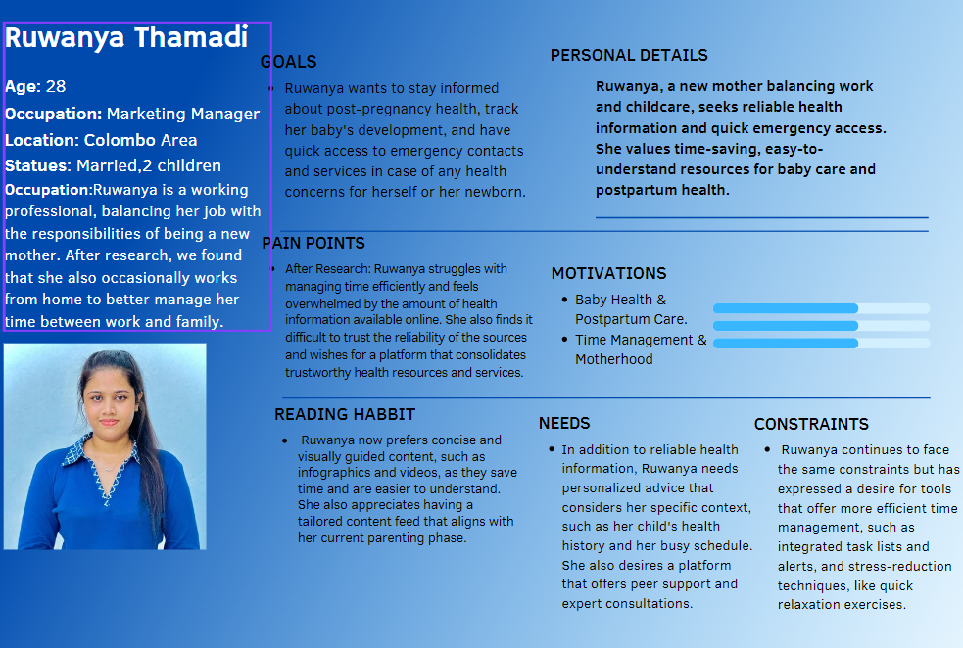

# Competitor Analysis

List some of the similar competitor programs or real-world solutions and discuss their advantages and disadvantages. For example, if you are developing a jobs website, competitors may be other job websites or a bricks and mortar HR company. The competitor does not have to be in the same domain but just represent a company that is solving a problem well. Describe some features that the other company does successfully that your team can borrow to use in the context that is relevant to your app.

Choose two or three competitors. Include your design thinking workshop showing your thorough analysis of their features and processes and how they may be translated to your app.

## <Competitor 1>

## Advantage

## Disadvantage

## Translation

## <Competitor 2>

## <and so on …>

# Milestone 4: Sketching

# Milestone 5: Wireframes, Prototype

This is where you showcase all the prototypes (low-fidelity and high-fidelity). Include as many significant low-fidelity designs as you developed. i.e. links to your Figma website.

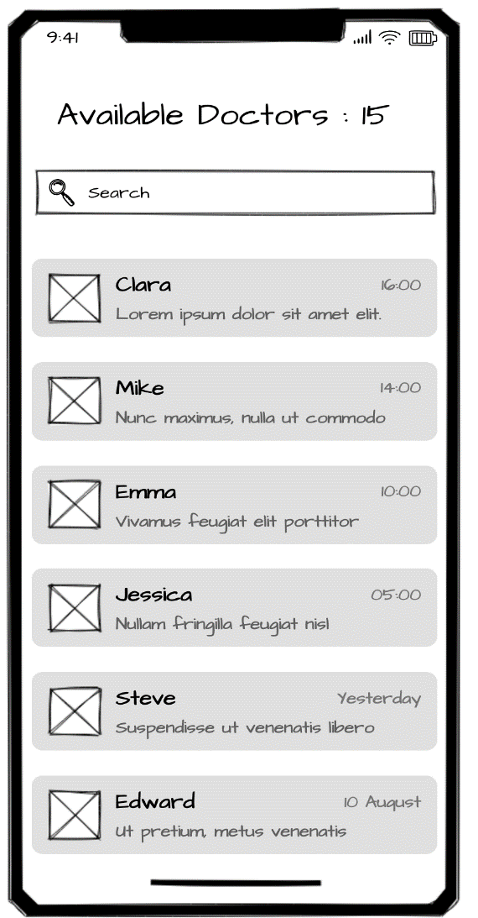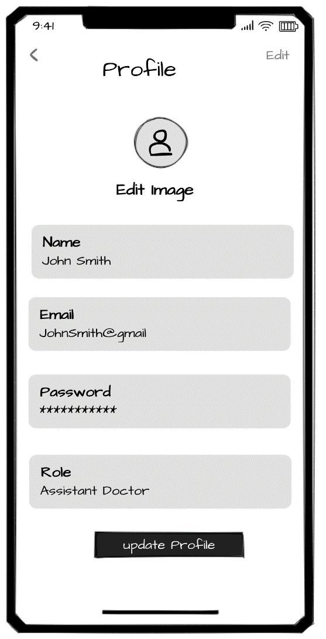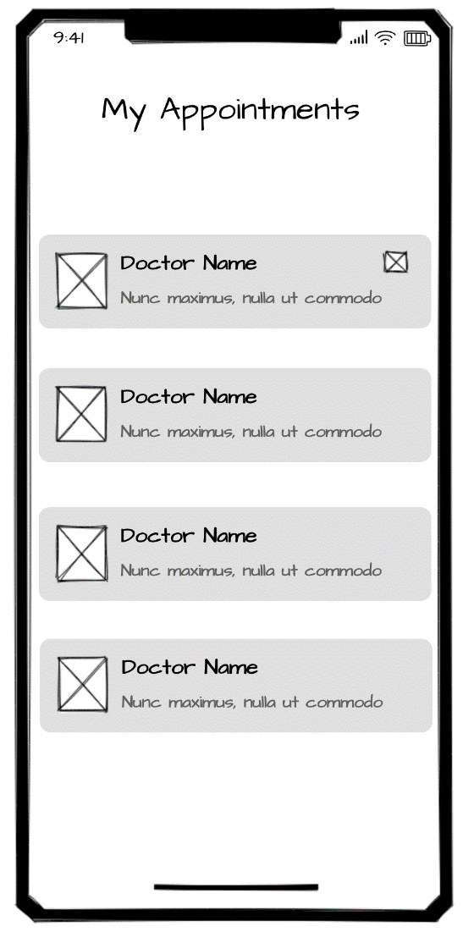

## Design 1

## Design 2 – accepted

## High Fidelity Prototype

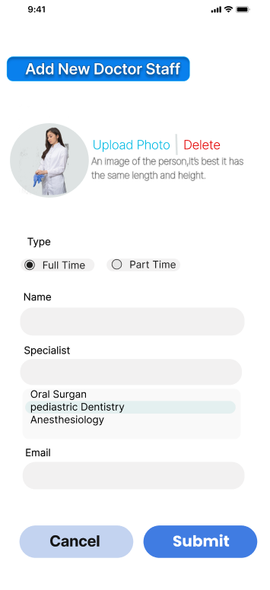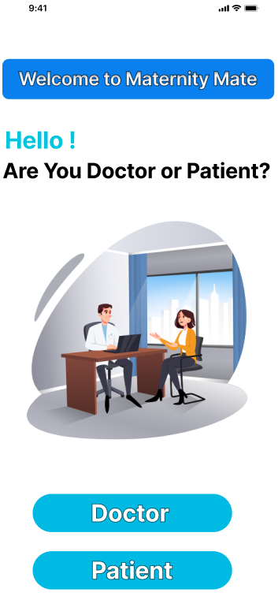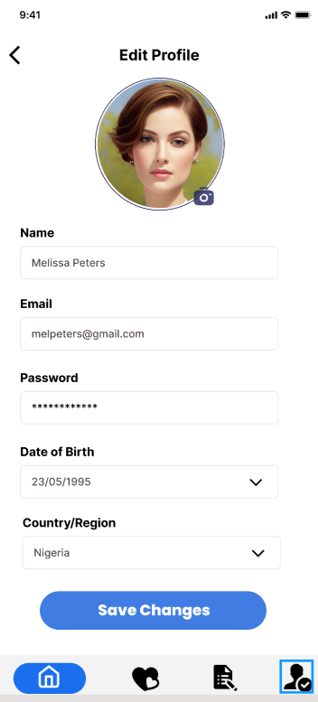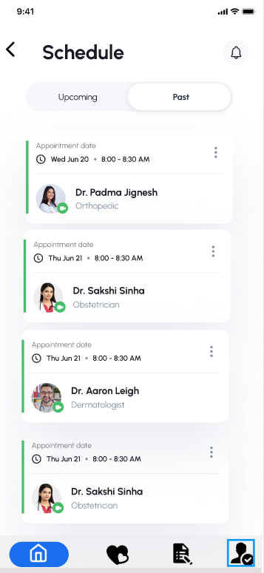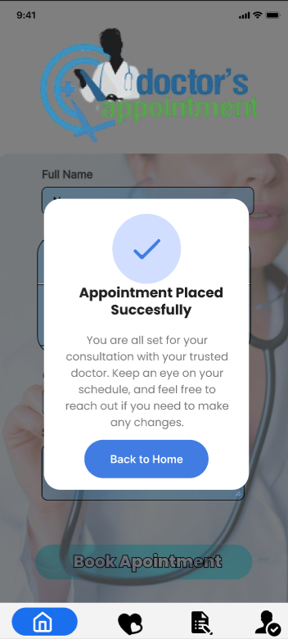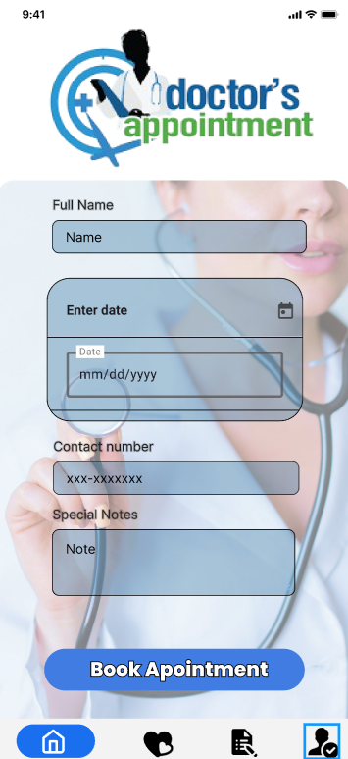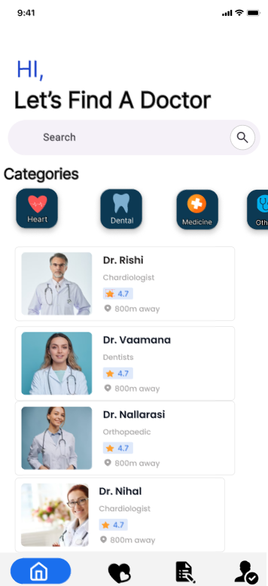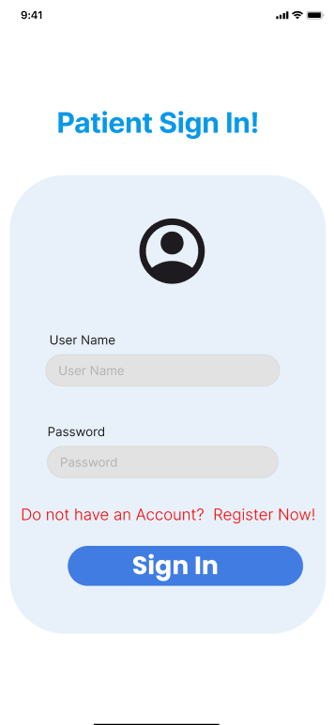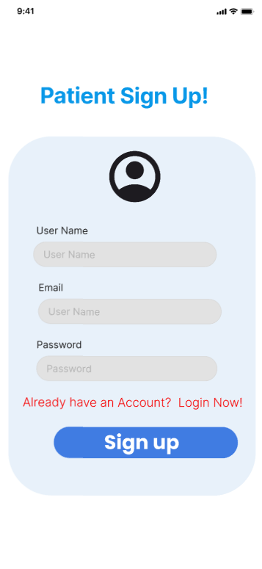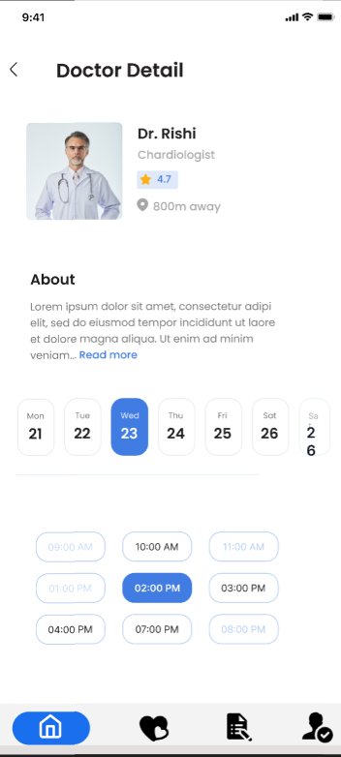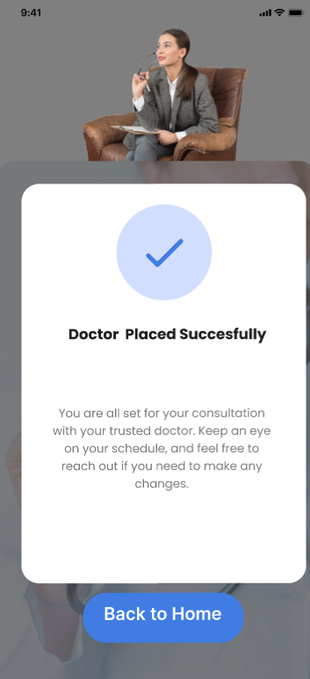

## Design 1

## Design 2 - accepted

Figma Link-<https://www.figma.com/design/VC27YvInorfXBI2YRAt0Ig/Untitled?node-id=112-2&t=Hg0GSN9ymxWCFdPt-1>

# Milestone 6: User Feedback for your Prototype

1. On App Usability:

The app is user-friendly, but sometimes I feel overwhelmed with the amount of information available. I would prefer having only relevant information tailored to my current needs, especially when I’m short on time.

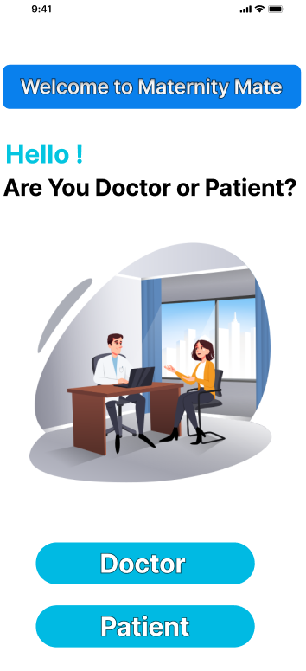

2. On Health Information:

I appreciate the detailed articles, but it’s hard to differentiate between reliable and generic advice. A section dedicated to expert-backed content or partnerships with certified health professionals would make me feel more confident.

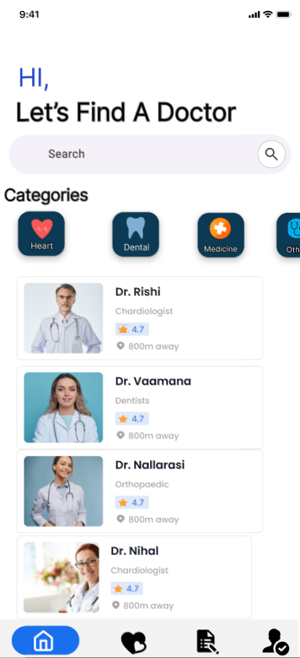

3. On Emergency Services:

I’ve struggled to find emergency contact information quickly when I needed it. It would be helpful to have a dedicated emergency button that instantly shows all the necessary contacts or services, along with my location.

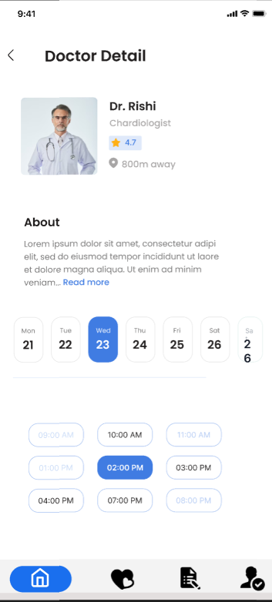

4. On Notifications and Alerts:

I sometimes forget about important checkups or vaccinations. The app should send reminders not only for my baby’s appointments but also for my postpartum health.

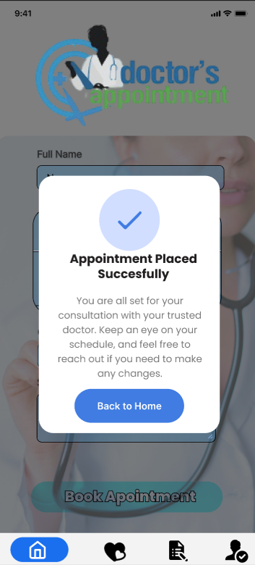

5.On Content Format:

While articles are informative, I don’t always have the time to read them. Shorter, visually rich content, like infographics or quick tips, would be easier to digest.

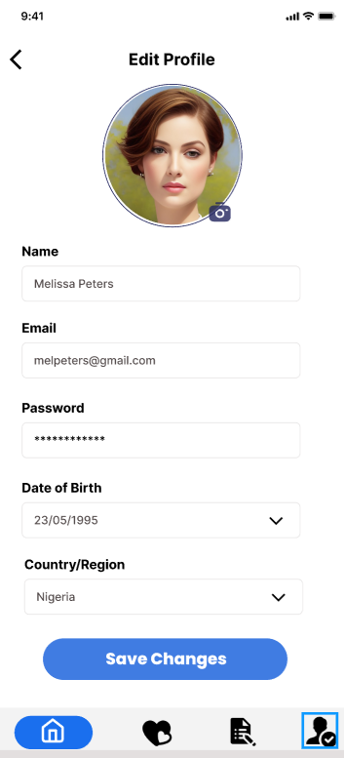

1. On Peer Support and Community:

It can be lonely trying to navigate motherhood and work simultaneously. I’d love a feature where I can connect with other moms, share tips, or even ask for advice when I’m unsure about something.

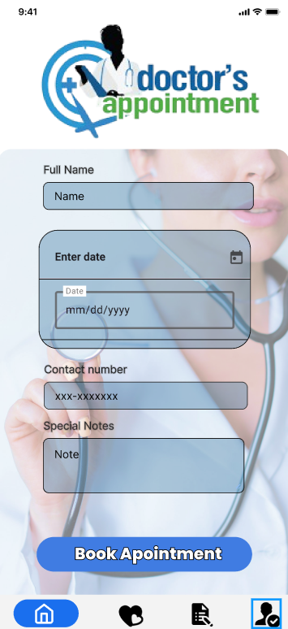

# Milestone 7: Implementation

* 1. **1. Technical Specifications**

**a. Choose a Platform:**

* **Platform:** Cross-Platform (React Native + Expo)
  + **Reasoning:** React Native allows for the simultaneous development of iOS and Android apps, making it ideal for reaching a wider audience while maintaining a single codebase. Expo enhances the development experience with a range of pre-built libraries and tools, simplifying testing and deployment.

**b. Technology Stack:**

* **Frontend:**
  + **Framework:** React Native (JavaScript)
  + **UI Library:** Expo for quicker development and built-in APIs
  + **Design Principles:** Material Design (Android), Human Interface Guidelines (iOS)
* **Backend:**
  + **Framework:** Firebase (No need for backend servers)
  + **Database:** Firebase Firestore for real-time database management and scalability
  + **Authentication:** Firebase Authentication (Google, Facebook, email sign-in)
  + **Storage:** Firebase Cloud Storage for storing media files (e.g., images, videos)
  + **Push Notifications:** Firebase Cloud Messaging (FCM) for sending notifications directly to users
    1. **2. Development**

**a. Frontend Development:**

* **UI Components:**
  + Develop reusable components adhering to design principles for consistency.
  + Use React Native libraries such as react-navigation for navigation and routing.
  + Create a responsive layout that adapts to both iOS and Android design conventions, keeping the user experience intuitive.
* **User Interface Guidelines:**
  + Follow Material Design for Android and Apple's Human Interface Guidelines for iOS, ensuring a seamless experience across both platforms.

**b. Backend Development:**

* **Firebase Integration:**
  + Implement Firebase Firestore as the real-time database for storing user data.
  + Use Firebase Authentication for secure and scalable user login and sign-up.
  + Implement Firebase Functions for serverless backend logic, reducing the need for maintaining external servers.
* **API Development:**
  + Use Firebase’s built-in REST APIs for real-time data updates, seamless syncing, and push notifications.
  + Implement GraphQL if additional custom queries or advanced data fetching is required.
    1. **3. Integration**

**a. Frontend and Backend Integration:**

* **Data Flow:**
  + Ensure smooth integration between React Native frontend and Firebase backend by utilizing Firebase’s SDKs.
  + Implement state management using redux or context API for easier data flow between components and Firebase.
* **Third-Party Integrations:**
  + Integrate third-party services like payment gateways (Stripe/PayPal) using Expo-compatible libraries.
  + Set up push notifications with Firebase Cloud Messaging (FCM) to notify users of important events (e.g., new messages, reminders).
    1. **4. Deployment**
* **Testing:**
  + Perform rigorous testing using Expo's development environment.
  + Use Firebase's Crashlytics for identifying and resolving any issues during testing.
* **Publishing:**
  + Leverage Expo's built-in functionality to publish the app on both Google Play Store and Apple App Store.
  + Perform app store optimization (ASO) by using relevant keywords and visuals to attract the target audience.

# **Milestone 8: Business Pitching for Investors**

* + 1. **1. Identify the Problem**
* **What you need to do**: Clearly define the problem or pain point your app addresses. Focus on inefficiencies, frustrations, or unmet needs within the target market that your app can solve.
* **Example**:
  + Problem: Many new and expecting mothers lack access to reliable, easy-to-understand information about their health and their baby’s development. Emergency services or health guidance may not be immediately accessible in times of need. Mothers are often overwhelmed by the multitude of scattered resources and advice.
  + Pain Points:
    - Difficulty finding personalized health guidance.
    - Lack of easily accessible emergency contact services.
    - Overload of conflicting information available online.
* **2. Understand the Target Audience**
* **What you need to do**: Conduct market research to define your target audience’s demographics, preferences, and behaviors. Consider their age, location, occupation, family situation, and other factors that may affect their need for your app.
* **Example**:
  + **Target Audience**: The primary audience is women between the ages of 20-40 who are pregnant or have recently become mothers. They are tech-savvy, balancing careers or household responsibilities, and rely on mobile solutions for health guidance and baby tracking.
  + **Demographics**:
    - Age: 20-40
    - Gender: Female
    - Location: Urban or semi-urban
    - Occupation: Working mothers, stay-at-home moms
    - Family Status: Married with children or expecting
  + **Behaviors**:
    - Frequently search for health information online.
    - Engage with apps for fitness, pregnancy, or healthcare.
    - Use smartphones for convenience, daily planning, and wellness tracking.
* **3. Define Unique Selling Proposition (USP)**
* **What you need to do**: Determine what makes your app stand out from competitors. What unique feature or value does your app offer that makes it more appealing? Consider both the functional and emotional benefits.
* **Example**:
  + **Unique Selling Proposition**: *A one-stop maternity care app that offers personalized health guidance, baby development tracking, and immediate access to emergency services—all in one simple, user-friendly platform.*
  + **Differentiators**:
    - 24/7 access to certified healthcare providers.
    - Real-time baby development tracking with expert advice.
    - Emergency contact features tailored to the user’s location.
    - Integration with health devices (e.g., smartwatches) for constant monitoring.
    - A supportive community feature where new mothers can connect and share experiences.
* **4. Develop a Monetization Strategy**
* **What you need to do**: Choose a monetization model that aligns with your app’s value and the behaviors of your target audience. Your revenue generation strategy should reflect the willingness of users to pay and how they are likely to engage with the app.
* **Monetization Options**:
  1. **Subscription Model**:
     + Offer a free version with basic features and a premium subscription for advanced features (personalized advice, direct access to experts, etc.).
  2. **Freemium Model**:
     + Users can access essential features for free, but more advanced features such as emergency contacts, health reports, or community forums are available via in-app purchases.
  3. **In-app Purchases**:
     + Users can buy additional content, such as specialized health guides, fitness plans, or e-books.
  4. **Advertisements**:
     + Partner with relevant healthcare brands or baby products to display ads, ensuring they align with the app's values and do not interfere with user experience.
  5. **Affiliate Marketing**:
     + Offer product recommendations (e.g., baby care products, fitness equipment) and earn commissions from purchases made through the app

# **Milstone 9:Business Pitching for Investors**

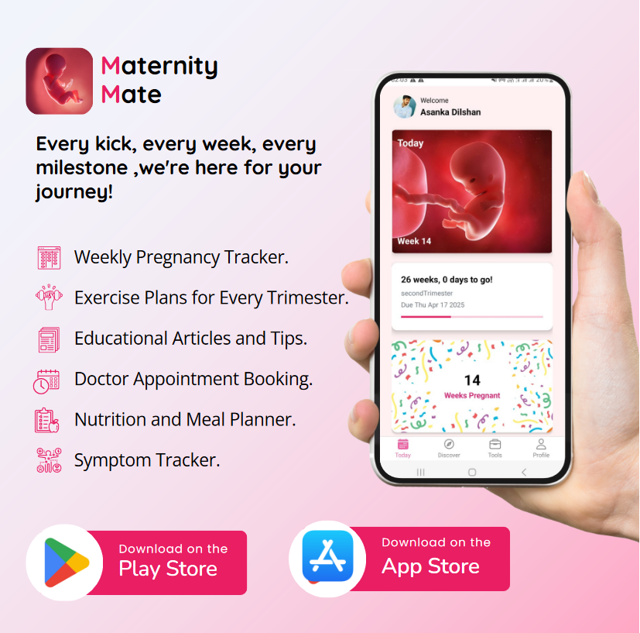

# 17 Requirement Specification

## Usability Goals

## The usability goals for Maternity Mate are focused on creating an intuitive, accessible, and easy-to-navigate app for expecting mothers:

## Ease of Use: The interface should be simple enough for users with minimal technical skills to navigate and use effectively.

## Efficiency: Users should be able to complete key tasks such as symptom tracking, appointment booking, and meal planning with minimal effort.

## Accessibility: The app should be accessible to all, including users with disabilities, ensuring compatibility with assistive technologies.

## Error Prevention: The design should minimize user errors and provide clear error messages and support for corrections if errors occur.

## 17.2 User Experience Goals

## The user experiences goals aim to provide a supportive and informative experience that empowers mothers and the whole family.

## Empowerment: Users should feel in control of their pregnancy by having access to essential resources and tools, such as nutritional advice and medical appointment management.

## Confidence: The app should help users feel more confident in their pregnancy journey by providing accurate, reliable information and support.

## Personalization: Users should experience a sense of personal connection through tailored content, reminders, and guidance based on their stage of pregnancy and preferences.

## Engagement: The app should encourage continued use with engaging features such as daily tips, exercise plans, and milestone tracking.

## 17.3 Functional Requirements

## Key functional requirements for Maternity Mate focus on the features that users will interact with:

## Symptom Tracker: Allows users to log and monitor pregnancy symptoms.

## Weekly Pregnancy Tracking: Provide updates on fatal development and tips relevant to the user’s week of pregnancy.

## Nutrition Meal Planner: Offer personalized meal suggestions based on nutritional needs.

## Doctor Appointment Booking: Enable users to book, track, and receive reminders for medical appointments.

## Exercise Plans: Provide customized exercises appropriate for pregnancy.

## Information and Educational Section: Offer articles, videos, and tips about pregnancy, healthcare, and maternal well-being.

## 17.4 Non-Functional Requirements

Non-functional requirements ensure that Maternity Mate performs well and offers a reliable experience:

* Performance: The app should have fast response times, especially for data-intensive features like meal planning and tracking.
* Security: User data, including personal health information, must be encrypted and stored securely, complying with health data regulations.
* Usability: The app must be easy to use, with clear navigation and user-friendly language. It should also minimize cognitive load.
* Localization: The app should support multiple languages and cultural contexts to cater to diverse users.
* Reliability: The app should be available with minimal downtime and provide consistent functionality without crashes or data loss.

## 17.5 Hierarchical Task Analysis

### 17.5.1 Doctor Appointment Booking Task

* Step 1: Navigate to the Doctor Appointment Booking section.
* Step 2: Select or search for a doctor.
* Step 3: Choose an available date and time from the list of options.
* Step 4: Confirm the appointment and receive a notification or reminder.

### 17.5.2 Information and Educational Articles Task

* Step 1: Open the app and navigate to the Discover section.
* Step 2: Browse categories (e.g., nutrition, symptoms, exercise, pregnancy health, baby care, maternal well-being).
* Step 3: Select an article or tip from the list of options.
* Step 4: Read or watch the content, with options to bookmark or save for later.
* Step 5: Optionally share the article with others (e.g., family, friends, social media).
* Step 6: After reading, receive related recommendations for further learning or similar content.

### 17.5.3 Nutrition Meal Planner Task

* Step 1: Open the app and navigate to the Nutrition Meal Planner.
* Step 2: Input personal details (e.g., trimester, weight, dietary preferences) or select previously saved settings.
* Step 3: View suggested meal plans for the day or week, tailored to nutritional needs for pregnancy.
* Step 4: Review or customize meals by selecting alternate options or ingredients based on dietary preferences.
* Step 5: Save the meal plan and optionally export or print a shopping list for the ingredients.
* Step 6: Track daily meals and nutritional intake by marking meals as “completed” or modifying based on actual consumption.
* Step 7: Receive feedback or suggestions based on meal tracking, such as recommended nutrient intake improvements.

### 17.5.4 Exercise Planning Task

* Step 1: Open the app and navigate to the Exercise Plans section.
* Step 2: Input personal information (e.g., current trimester, fitness level, and any medical conditions) or use previously saved settings.
* Step 3: View a list of suggested exercises tailored to the current stage of pregnancy.
* Step 4: Select an exercise plan for the day or week.
* Step 5: Review detailed instructions, videos, or guidelines for each exercise.
* Step 6: Optionally customize the plan by adding or removing exercises.
* Step 7: Begin the exercise routine, with options to mark each exercise as complete or track progress.
* Step 8: Review the session summary and receive feedback, such as health insights or tips based on performance.

### 17.5.5 Symptom Tracking Task

* Step 1: Open the app and navigate to the Symptom Tracker.
* Step 2: Enter daily symptoms (e.g., nausea, headache) using a pre-set list or custom entry.
* Step 3: Review logged symptoms and get insights or alerts based on patterns (e.g., frequency of symptoms).

# Design Principles

What design principles did you use?

# Project Management

Describe the evaluation of your overall design process.

## Meetings

Describe how you conduct meeting (frequency, deadline, communication platform, etc..)

## Risk Management

Describe any risk to be considered when you are completing this project.

## Milestones

Put your milestones timeline here.

## Problems Encountered

Any unexpected obstacles? Put it here and describe how you address them.

# Conclusion

* Maternity Mate is a comprehensive maternity care app designed to support and empower expecting mothers throughout their pregnancy journey. It offers a range of features that cater to both health management and educational needs. The app includes Weekly Pregnancy Tracking, allowing mothers to monitor their pregnancy progress and receive relevant tips. The Symptom Tracker helps log and manage any physical changes or concerns, ensuring that users can keep an eye on their well-being.
* What sets Maternity Mate apart from other apps are its unique features like the Nutrition Meal Planner, which helps mothers create balanced meal plans to meet their nutritional needs, and the Doctor Appointment Booking function, which simplifies scheduling medical visits. Additionally, the app provides Exercise Plans tailored to pregnancy and access to a rich library of Educational Articles and Tips aimed at empowering mothers with essential knowledge. Overall, Maternity Mate delivers a holistic pregnancy care experience, combining convenience, health management, and educational resources to support mothers at every stage of their journey.

# References

List any references you use for this report such as figures, tables, screenshots, or websites.

# Glossary

# Appendix

## Initial User Survey Responses

This includes survey/questionnaire questions you write to get relevant data.

## Meeting Minutes

List all the meeting minutes that you record for this assignment.

## Record Keeping

## Toggl tracking

Use toggl to track each team members hours and present a neat summary here.

## Links to Google Docs / MS Teams

## Contribution Table

Create a table that lists team members contributions towards each section in this report. Multiple group members can contribute to any single section.